LANCASHIRE BEST KEPT VILLAGE COMPETITION
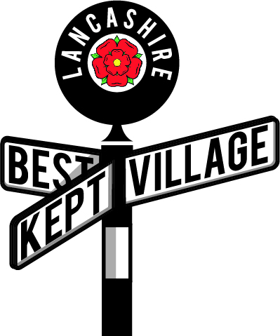
Judges Report 2021

Judges – please reflect on your two visits and fill in a report so that it can be sent to the village you have visited. Your names should not be given to the village – just indicate whether you are Judge 1 or 2.
Ideally it is completed, a paragraph under each of the first three headings given below as, a word document but a handwritten report on the back of this sheet is OK if you do not have a computer. Please don’t send PDF copies.
(The Committee reserves the right to edit the report prior to forwarding it to the village)

Villages – please accept the report written by your judges who will try to give constructive criticism as well as praise to help you to improve your entry next year.

1)Overall Impressions (Include comments on: tidiness, amount of litter/weeds/graffiti and whether there was a sense of pride and community involvement)
2)What makes it Best Kept? (Include comments on: any areas or features where the village or the owners of the property or business had taken special measures to improve or enhance the appearance of the village.)
3) Areas of Improvement (Include comments on: any area which may be improved and how this could be done so that they do not detract from the rest of the village.

Village map (Include comments on: whether the print was clear, whether the area to be judged was clear and things like bus shelters, benches etc where indicated and whether all the outstanding features were clearly marked.

Name of Village __Belmont______________________ Judge 1 /

Date of Visit 1 _16th June_______

Date of Visit 2 __9th July________

Overall Impressions
Belmont is a delightful village to wander around. Blessed with fabulous views over the countryside, and lots of water features it is a huge spread to look after, so all credit to the community.
Although some litter and weeds were to be seen, mainly on the roadways and verges, there was a clear sense of community pride in their environment. No graffiti was seen at all.

What Makes it Best Kept?

The individual homes were a pleasure to see, especially the cottages along the main road where floral displays were lovely. The school is superb, with a lovely, well cared for building and interesting, varied features to the grounds and garden. Special mention to Lotties Café, a lovely, well kept little business with a pretty garden. Perhaps this could be considered for an Outstanding Feature in future? Particular mention to the bus stops, which were in a very clean condition indeed, which is rarely seen.

Areas of Improvement

Not really much to do except to keep on top of the litter along the main roads especially the left hand side going out of the village towards Hoghton. Some really interesting and unique assets, such as the obelisk to the Reservoirs, could be featured more, with perhaps more eye catching planting around. There were a few weeds on our second visit there. The Dog Inn too, could maybe have put up more of their hanging baskets, stashed in the car park. The Church was lovely – a little more care of the individual plots could be encouraged and painting of the rear gate would be a welcome improvement.

Map.

We had two, the first was pretty basic but the second one, sent later, was superb in detail. 10/10.

