LANCASHIRE BEST KEPT VILLAGE COMPETITION
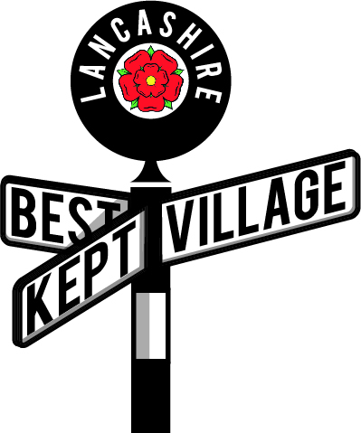
Judges Report 2021

Villages – please accept the report written by your judges who will try to give constructive criticism as well as praise to help you to improve your entry next year.

Chapeltown is a very lovely village and it was a pleasure to visit. There was no litter at all in the village. All in all a lovely area which gave the impression of pride taken in the surroundings.

The public gardens inside the church ground were well kept and very attractive. The graveyard is extensive and although the grass had been cut there was some tidying up required.

The memorial garden within the church grounds is extensive and had a lovely flower border on the perimeter as did the rest of the church area but the paving in the memorial garden needed some attention. There was a large composting area hidden away in the church grounds which was good to see.

The houses on the main road through Chapeltown nearly all had flower displays or well-kept gardens and the area around Tower Street, a traditional terraced area was lovely with a hidden seating area which could constitute an outstanding feature in the future.

The football club was very impressive and extremely well maintained.

The pub had some new wooden window boxes on all the windows but the plants were not matured and the display could have been bigger. The playing area by the church was in use on both visits but the equipment is very basic and the seating required attention.

The map was clear and easy to follow.

Name of Village: Chapel town

Date of Visit 1 30 June 2021
Date of Visit 2 10 July 2021

