LANCASHIRE BEST KEPT VILLAGE COMPETITION
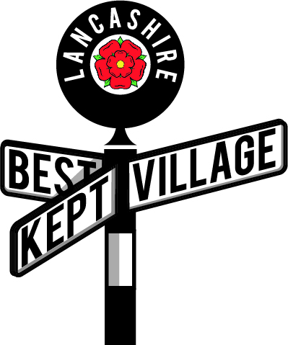
Judges Report 2021

Judges – please reflect on your two visits and fill in a report so that it can be sent to the village you have visited. Your names should not be given to the village – just indicate whether you are Judge 1 or 2.
Ideally it is completed, a paragraph under each of the first three headings given below as, a word document but a handwritten report on the back of this sheet is OK if you do not have a computer. Please don’t send PDF copies.
(The Committee reserves the right to edit the report prior to forwarding it to the village)

Villages – please accept the report written by your judges who will try to give constructive criticism as well as praise to help you to improve your entry next year.

Edgeworth was a pleasure to visit, the Litter Man and community do an excellent job as we saw no litter at all during our visits.

The majority of houses and businesses had well kept premises and gardens an both the cricket ground and bowling green are in excellent condition all showing a great pride in their village.

Although there were no bowling matches on either days we visited the bowling green perimeter was busy with lunch time diners using the benches around the perimeter of the green which was nice to see.

The area of shops we have commented on was at the top of the village on Blackburn Road were lovely all the shops had well-kept premises with lovely window displays which would encourage you to enter.

Barlow Court was also well-kept, and it was a shame that we did not get to see the area around The Barlow Village Hall and play area but it was extremely busy with contractors and the building covered in scaffolding which was outside the control of this entrant. The notice board outside The Barlow was well maintained.

The map was easy to follow but we did not find the monument (no 7) missing off the

Name of Village Edgeworth

Date of Visit 1 _____30 June 2021______

Date of Visit 2 ______10 July 2021______

