LANCASHIRE BEST KEPT VILLAGE COMPETITION
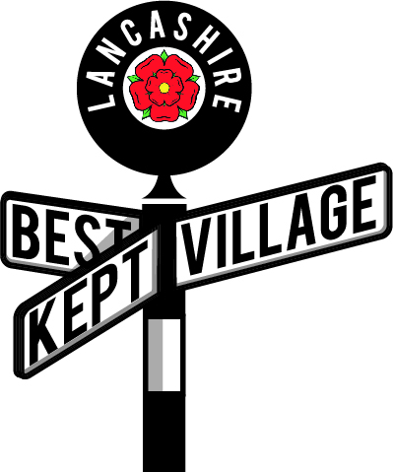
Judges Report 2021

Judges – please reflect on your two visits and fill in a report so that it can be sent to the village you have visited. Your names should not be given to the village – just indicate whether you are Judge 1 or 2.
Ideally it is completed, a paragraph under each of the first three headings given below as, a word document but a handwritten report on the back of this sheet is OK if you do not have a computer. Please don’t send PDF copies.
(The Committee reserves the right to edit the report prior to forwarding it to the village)

Villages – please accept the report written by your judges who will try to give constructive criticism as well as praise to help you to improve your entry next year.

1)Overall Impressions (Include comments on: tidiness, amount of litter/weeds/graffiti and whether there was a sense of pride and community involvement)
2)What makes it Best Kept? (Include comments on: any areas or features where the village or the owners of the property or business had taken special measures to improve or enhance the appearance of the village.)
3) Areas of Improvement (Include comments on: any area which may be improved and how this could be done so that they do not detract from the rest of the village.

Village map (Include comments on: whether the print was clear, whether the area to be judged was clear and things like bus shelters, benches etc where indicated and whether all the outstanding features were clearly marked.

Name of Village ___Edgworth_____________________

Date of Visit 1 18/6/2021

Date of Visit 2 08/07/2021________________________

Judges Report – Edgworth

Overall Impression
A pleasant and attractive village, with no sign of litter or graffiti.
What makes it Best Kept
The central area comprising the Village Hall (The Barlow), which was under repair, the bowling green, cricket field and playground are an exceptional asset to the village.
The new playground can’t be faulted, although we are not sure how much use of it has been made yet.
The absence of litter and graffiti, combined with well kept private housing and commercial premises, and the provision of planters adds to the overall good impression.
The Black Bull had made a good effort, and could have been nominated in the ‘outstanding feature category.
.

Areas of Improvement.
Weeds were evident in most of the roads, growing in the gutter, or alongside the house walls, and the local council needs to be prompted to get on top of these. It was noticeable that Broadhead Road was an exception here.
There were some verges with high grass, eg Moorfield, but this was better on our second visit. While Sharples Green had been mown, most of Sharples Meadow had been left with long grass.
Weeds were also evident in the paving on other properties, including Barlow Court.
While the sports ground was very good, it could be improved if the patches of artificial grass could be replaced with actual grass.

Map
It was good to have a map with the area to be judged, in addition to one giving the location of the features, however the latter mentioned a reservoir, which was not in the judging area marked on the map. Could this be clarified.

